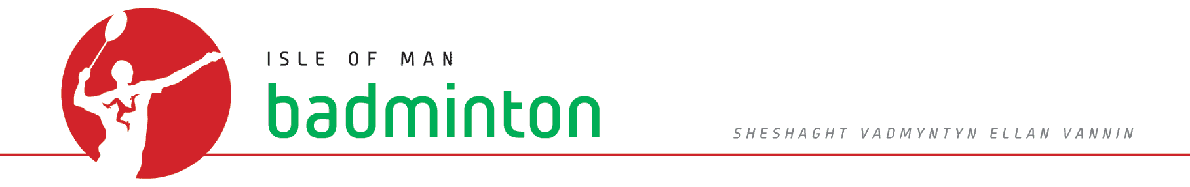
ISLE OF MAN BADMINTON ASSOCIATION JUNIOR EVENTS

U13 Callin Wild Championship held on 19 October 2013 results

Boys Singles Winner: Matthew Gawne
Runner Up : Alex Buck
Semi- Finalists : Jake Vance & Harry Walters

Girls Singles Winner : Megan Wade
Runner up : Hollie Robertson
Semi-finalists : Laura Parkinson & Milly Avery

Boys Doubles Winners : Alex Buck & Matthew Gawne
Runners up : Josh Mills & Harry Walters
Semi-finalists : Joel Avery & Jake Vance/Tobey Cheng & Sam Callow

Girls Doubles Winners : Megan Wade & Laura Parkinson
Runners up : Leah Masson & Katie O’Connor
Semi-finalists : Katie Kewley & Francesca Avery/Kira Stewart & Milly Avery

Mixed Doubles Winners : Matthew Gawne & Megan Wade
Runners up : Alex Buck & Kitty Thomas
Semi-finalists : Benjamin Li & Leah Masson/Saul Parry & Hollie Robertson

